**Project Proposal**  
**Project Name:** Autonomous Vehicle Scenario Modeling  
**Project Team Members:** Isabella Acosta, Serena Conticello, Hannah Ramsden, William Reimer, Davian Rosario-Ortiz

**Problem Statement:**

With the rise of automated vehicles, there is a need for an accurate and safe decision-making framework. An option for testing is PolyVerif, an open-source tool for autonomous automotive simulation. The software currently supports a wide variety of vehicles, ranging from cars to UAVs. It focuses on validation and verification using a multitude of scenarios, all of which demonstrate its adaptability and engagement within a given environment. PolyVerif’s compatibility with the widely used modeling language Scenic, and its ease of customizable vehicle specifications and its surroundings makes this an intuitive choice for advancing the safety of future roads.

This project has two goals for the start of its lifecycle. The first will be to expand upon the application space within PolyVerif, where 3D real-world inspired test environments are created for simulations. The second will be to integrate evolutionary artificial intelligence models (i.e. Neuroevolution) within testing to improve validation and accuracy within current and future systems. The initial specific goals are as follows:

1. Creation of multiple test scenarios using the Embry-Riddle Aeronautical University (ERAU) Daytona Beach campus model with increase in complexity of scenarios like Lane Changing, Overtaking, Blind Spot, Collision etc. and analyze validation results of each scenario.
2. Analysis of detection validation with different conditions such as different weather conditions, speed variations, traffic conditions, road conditions etc.
3. Sensor model updates such as noise additions (reflectivity parameters etc.) to sensor model and see the changes in Validation results.
4. Integration of PolyVerif with the testing platform designed by Dr. Akbas’ group.

**Why is it a problem?**

PolyVerif provides itself as a noteworthy option in autonomous vehicle testing. However, seeing as preliminary documentation and software dates back as early as 2021, it is still a relatively new tool on the market. A lack of sufficient testing scenarios within PolyVerif’s database leaves room for improvement, which is within the scope of this project’s goals. To expand the testing within PolyVerif, Embry–Riddle Aeronautical University will be utilized as a testing ground. The campus provides a set of unique scenarios with varying traffic laws, object interactions, and traffic patterns. This should provide the necessary dynamic and customizable plane to bolster PolyVerif’s capabilities.

**Stakeholders:**  
**Primary Stakeholders:**

* AVVC
* Project Owner – Dr. Akbas
* Research group of Dr. Akbas

**Secondary Stakeholders:**

* Passengers using autonomous cars
* Researchers using software to accelerate research done on autonomous vehicle testing
* Manufacturers implementing autonomous car algorithms

**Proposed Solution:**

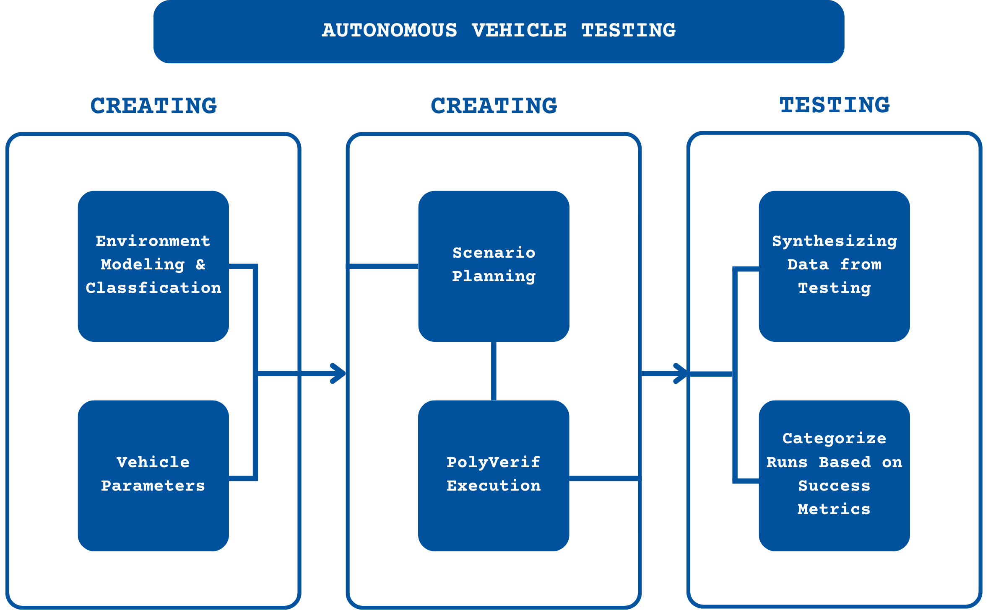

**Languages to be Utilized:**

* Scenic 2.0.0
* Python 3.8

**Software to be Utilized:**

* PolyVerif
* Blender 3.5
* MapsModelImporter Plugin 0.6.2
* RenderDoc 1.26
* LGSVL 2020.06

**Operating System to be Utilized:**

* Ubuntu 18.04

**Hardware to be Utilized:**

* All computers compatible with the following constraints
  + NVIDIA 1090 Graphic Card (or better)

**Roles:**

* Simulations and Scenario Testing
* Simulation and Scenario Design
* Digital Mapping
* Reporting/Recommendations
* Management

**Semester 1:**

The main goal to be completed in the first semester is modeling a vehicle intersection within the ERAU Daytona Beach campus. PolyVerif will be utilized to simulate all possible actions that could logically occur at the modeled intersection in an atomic manner. The main steps involved are as follows:

* Generate 3D model of ERAU campus and heavy traffic intersections within a half mile of ERAU campus by using Google Earth’s mapping functions with Blender.
* Determine primary and secondary intersections for modeling, having primary being the main goal of the first semester, and secondary being second semester.
  + Primary intersections will be simple, with basic traffic patterns to be modeled.
  + Secondary will be more complex, with advanced testing scenarios.
* Classify and test obstacles, roads, and parameters within 3D rendering model.
* Determine applicable and atomic scenarios for primary intersections.
  + Determine criteria for success for each scenario.
* Determine applicable and atomic scenarios for secondary intersections.
  + Determine criteria for success for each scenario.
* Implement primary intersection scenarios using Python and Scenic.
* Test scenario verification with Polyverif and repeat for each scenario within primary intersection.

Other goals include learning and understanding the PolyVerif software and further resources which can contribute to its advancement. With this familiarity of the technology involved, the team should be able to run 1-2 simulations per scenario.

An ideal, but likely out of scope, goal would be to integrate data from active autonomous vehicle hardware.

**Semester 2:**

For the continuation of this project, the second part of our main goal is to determine secondary intersections and model complex scenarios. At the time of this document’s creation, there is the possibility of an update to Polyverif in the second semester’s time frame. We will be allotting time to research this update and familiarize ourselves with it to ensure that design and implementation can be continued as smoothly as possible. This semester’s plan should involve more vehicles, more circumstances, multiple intersections, and an overall greater simulation scale. A tentative timeline is as follows:

* Update 3D model of campus for obstacle accuracy and landscape details.
* Revaluate secondary intersections and determine scenario cases.
  + Planned to model two more intersections, more complex and in depth than first semester’s model.
* Determine applicable scenarios for secondary intersections.
* Determine criteria for each scenario.
* Implement secondary intersection(s) scenarios using Python and Scenic.
* Test scenario verification with Polyverif and repeat for each scenario within secondary intersection(s).
* If necessary, determine alternative simulation framework.

Ideally the integration of Neuroevolution would be another goal. However, this is contingent on the successful completion of the primary objectives.

* Research machine learning applications within autonomous vehicle testing.
  + This will include determining if machine learning is better suited for scenario modeling, evaluation, or classifying obstacles.
* Implement a basic Neuroevolution model based on research results.
* Test model against human usage to determine effectiveness and evaluate.

**Proposed Project Budget:**  
This project currently requires no money, as all software is open source, and all necessary hardware has been provided within the MicaPlex.

**References:**

Akbaş, M. I., Menase, M., Verma, S., & Razdan, R. (2024). PolyFlows: Modular Test Framework Design for autonomous vehicles. *2024 IEEE International Conference on Mobility, Operations, Services and Technologies (MOST)*, 50–59. <https://doi.org/10.1109/most60774.2024.00014>

Autonomous Vehicle Verification Consortium. (n.d.). <https://www.avvc.net/>

Fremont, D. J., Dreossi, T., Ghosh, S., Yue, X., Sangiovanni-Vincentelli, A. L., & Seshia, S. A. (2019). Scenic: A language for scenario specification and scene generation. *Proceedings of the 40th ACM SIGPLAN Conference on Programming Language Design and Implementation*. <https://doi.org/10.1145/3314221.3314633>

*Introduction#*. SUMO Documentation. (n.d.). <https://sumo.dlr.de/docs/index.html>

Razdan, R., Akbaş, M. İ., Sell, R., Bellone, M., Menase, M., & Malayjerdi, M. (2023). PolyVerif: An open-source environment for Autonomous Vehicle Validation and Verification Research Acceleration. *IEEE Access*, *11*, 28343–28354. <https://doi.org/10.1109/access.2023.3258681>

M. I. Akbaş, M. Menase, S. Verma and R. Razdan, "PolyFlows: Modular Test Framework Design for Autonomous Vehicles," *2024 IEEE International Conference on Mobility, Operations, Services and Technologies* 10.1109/MOST60774.2024.00014. <https://ieeexplore.ieee.org/document/10607079>